Research proposal: a surface physics puzzle
A J Gordon-Wright
Department of Physics, University of Bath, Bath BA2 7AY, United Kingdom

1. Background
1.1. Introduction
This proposal stems from a 2008 paper by Alexandrowicz et al. [2], in which the authors present some interesting new results on the dynamics of CO molecules adsorbed onto a Pt(111) surface. Their results, which will be discussed in more detail later, seem to suggest that there is no repulsive pairwise interaction (i.e. an interaction that depends on the nature of the two particles interacting and their separation only, and not on the substrate medium) between CO molecules on the surface. This seems to be in direct contradiction to the results of many previous experimental studies (e.g. [3-5]). These studies show that, as more CO molecules are added to the surface and therefore the surface coverage increases, the heat of adsorption (i.e. the binding energy of the added CO molecules) decreases monotonically. This has been interpreted in these and other studies to show that there must be a repulsive interaction between CO molecules, so that they are easier to remove with more CO neighbours. The ultimate aim of this project is to use quantum mechanical computational calculations to assess whether one or both of these interpretations are wrong, by calculating the binding energies of CO for various coverages and surface geometries.
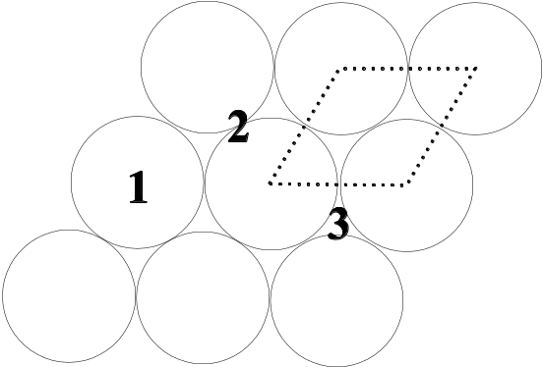
Figure 1. Lattice structure of Pt(111), showing potential sites for chemisorption (1-3) and primitive unit cell (dotted line)

To understand [2] and its implications, as well as the interpretations of previous results, it is necessary to have knowledge of some of the techniques and terminology of surface science. The remainder of this background section will attempt to elucidate these, as well as to summarise [2].

1.2. Surfaces and adsorption
Surface planes generated by cleaving bulk solids are described by Miller indices [6]. These come in the form of three numbers in brackets, denoted by (hkl). To calculate these, the points at which a plane crosses each of the three space axes, expressed in terms of the number of lattice basis vectors from the chosen origin, are found. The indices are given by the smallest set of integers with the same ratio as the inverses of these intercepts. The geometry of each plane varies depending on the crystal structure in question. The planar structure of Pt(111) is given in figure 1. It can be seen that this is a hexagonal lattice, with the dotted line representing the unit cell of the lattice, the unit that is repeated to create the full structure.

A molecule or atom adsorbed onto a surface is denoted by Ad/B(hkl), where Ad is the adsorbed species and B(hkl) is the surface plane. Ad can be adsorbed onto the surface in two ways: physisorption or chemisorption. In physisorption, molecules/atoms of Ad are weakly attached by van der Waal’s forces, whereas in chemisorption they are much more strongly attached by surface chemical bonds [6]. The dominant mechanism for CO/Pt(111) is chemisorption. In addition, there are two types of chemisorption for molecules: dissociative or non-dissociative. In dissociative chemisorption, the adsorbed molecule breaks up into its constituent atoms. The dominant mechanism for CO/Pt(111) is non-dissociative (it stays in its molecular form.

CO can attach on one of three possible sites in the Pt(111) plane: atop, bridge and hollow (denoted by 1, 2 and 3 in figure 1). These sites are all minima in the potential energy of the surface, however calculating their exact values, and hence which sites are preferred for binding, is challenging [7]. The adsorbed molecules could attach in a disordered fashion, with no discernible structure, however studies using techniques such as low energy electron diffraction (LEED), which explicitly visualises the adatom positions, have shown that there is usually an ordered lattice structure [3]. This structure is denoted by a version of Wood notation, which is also used for reconstructed surfaces (not considered here). This notation is generally given as follows: Rϕ º, where n and m denote the size of the adsorbed lattice unit cell, in multiples of the surface unit cell (i.e. they represent scaled versions of the dotted shape in figure 1), and ϕ represents the angle of rotation between the adsorbed lattice unit cell and the surface unit cell [6]. These adsorbed lattice structures are an important part of this investigation, as repulsive forces between the adatoms will have a major influence on the lattice structure.

The LEED study mentioned above [3] shows that the lattice structure changes as a function of coverage, θ. [Coverage is expressed in units of monolayers (ML), which are measured as the fraction of the number of surface atoms. For example, if for a given surface area there are the same number of adatoms as surface atoms, θ = 1.] It is shown that, as q increases, the preferred adatom lattice structure changes from (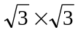)R30º, to c(2 x 4), and finally to a hexagonal close packed (HCP) plane structure at higher coverages. These changes will be investigated in the experiment, by the calculation of total energies for these structures at different coverages, hence finding the preferred structure.

1.3.Helium spin-echo spectroscopy
The main experimental technique used in the Alexandrowicz et al. study was helium spin-echo spectroscopy (³HeSE). This is a relatively new, and very powerful, technique for measuring surface structure and dynamics. First developed in 1995 by DeKieviet et al. [8], it has since grown in usefulness and versatility [9]. A beam of ³He ions is focused and polarised, then sent through a magnetic field. This adds a phase to the spin. After reflecting off a surface, and hence changing wavelength, the beam is sent through a second identical field, which adds a different phase to the spin as this is wavelength dependent. By sending this beam through a second polariser/focuser, the intensity of the beam for different phases is changed (by a known amount). Hence, by measuring this final beam, the phase can be measured, and from that the scattered wavelength and therefore scattering energy can be measured, to very high accuracies [9]. To study surface dynamics, a beam with ions of two opposite spins is used. The two spins are accelerated by different amounts in the first field, so that they interact with the surface at different times. By measuring the differences between the two spin beams, the change in the surface over this period can be found. This allows for the study of ultra-fast surface dynamics, in this case the motion of the adsorbed CO.

1.4. Alexandrowicz et al. (2008) [2]
The authors use ³HeSE to measure the inverse lifetime α of the intermediate scattering function (ISF), which is the spatial Fourier transform of the time-dependent pair correlation function G(R,t), proposed by Van Hove [10]. The pair correlation function measures the probability of finding a particle at a position R after a time t, given the existence of a particle at the origin at t = 0. The ISF decays with time, and their apparatus measures this decay as a function of the momentum transfer K involved in the scattering event. This leads to the inverse lifetime. Results for this relationship are found for different coverage. The results show that the functional form of the α(K) relationship does not depend on the coverage, which the authors assert shows that there in no correlated motion of surface adatoms. Correlated motion would mean that the inverse lifetimes would not change uniformly for different coverages. As pairwise interactions necessarily lead to correlated motion, the authors therefore conclude that the pairwise forces (if they exist at all) are negligible, contradicting previous conclusions as mentioned above.

The authors go on to use molecular dynamics (MD) simulations to calculate inverse lifetimes for various pairwise interactions previously proposed, and show that indeed none of these can generate the observed data.

The analysis involved in this paper is perhaps more subtle than the previous analyses. Hence, it could be susceptible to subtle flaws. A major part of this project will be to attempt to reproduce this analysis (perhaps excluding the MD calculations depending on time), to check for errors and incorrect assumptions. By comparing this with previous experimental results, and the results generated in this project, it is hoped that some light can be shed on these puzzling contradictions.

1.5. Density functional theory calculations
The computational technique used in this study will be quantum mechanical calculations based on density functional theory (DFT). This theory builds on work by Hohenberg and Kohn [11], and later work by Kohn and Sham [12], which shows that, when calculating the behaviour of the valence electrons in the ground state in a solid, the interactions of the valence electrons with the core electrons and the nucleus can be simulated using a density functional (a function of the electron density), rather than a full potential for each core electron. A functional called the exchange-correlation (XC) is used, which represents both the interactions with the core electrons and nucleus, and with an external potential. This is called a pseudopotential [13] . This greatly reduces the total number of calculations, making the calculation of electron properties over a solid at least theoretically possible. In practice, some further approximations are required. The use of supercells or clusters is particularly important. Essentially, the bulk solid is represented either by a collection of slabs (supercells), or by a cluster of atoms [14]. This again greatly reduces the number of calculations. The electron wavefunctions are represented by a plane-wave expansion (similar to that used in Fourier analysis). This expansion will be cut-off at a certain point, again to simplify calculations. Finally, gradient-corrected density functionals (based on theories such as the generalised gradient approximation [GGA]), are used to improve accuracy.

For this study, the PW-SCF (plane-wave self-consistent field) DFT package will be used. This is treated as a “black-box”, i.e. after learning about the inputs required, the code will be run, but the actual structure of the code itself will not be studied in any detail.

2. Project objectives
The main objectives of this project are as follows:

1. Learn to run the PW-SCF code:
- Learn how to use UNIX bash scripting to automate jobs, to save time.
- Learn how to use the University’s High Performance Computing cluster (HPCC). This is a recently installed cluster, currently with 200 cores, which is necessary to make the required calculations calculable in a reasonable time.
- Finally, learn what the required inputs to PW-SCF are, and run it for a few small test cases (e.g. bulk Pt, single CO molecules). Successful running of a test case is an important milestone.

2. Learn how to set-up PW-SCF for Pt surface calculations. This may require some complicated inputs. The first surface calculation is another milestone.

3. Add CO molecules onto this surface:
- Firstly, calculated binding energy for just a single CO adatom.
- Next, increase the coverage and recalculate, and repeat for various coverages. Aim to generate results for 5 coverages.
- Finally, calculate for various CO lattices on the surface, as well as some disordered structures if possible. Aim to investigate 2 lattices for two coverages. The completion of all PW-SCF simulations is a milestone.

4. Analyse these results, in relation to the Alexandrowicz et al. [2] results, and previous experimental data. Analyse [2] in detail, ideally with access to the original data, and attempt to reproduce the results and come to a conclusion. The detailed conclusion is another milestone.

5 (Optional, if there is time). Develop and run an MD simulation of CO/Pt(111), to study surface dynamics, and further enhance the analysis of [2].

6. Disseminate the results, via a written report and a short presentation. Completion of both of these are the final two milestones. They are also the deliverables from the project. The dissemination of results will hopefully further understanding of this field.

3. Project organisation
This project fits well within the organisation of the Department, as shown by figure 2. The supervisor, Professor David Bird, has much experience in the DFT field (e.g. [14]), and is still active in research.

The project fits within the Condensed Matter Theory group, whose research areas include both surface and bulk physics. This piece of research will therefore be of interest of the group. As such, it is proposed to attend the regular meetings of this research group, where members discuss their current research. This will provide immersion into the field, and potentially could throw up some interesting ideas to do with the project itself. There is also the potential for a short presentation on the project to be given to the group, which could stimulate useful discussion.
Faculty of Science
Department of Physics
Condensed Matter Theory Group
Prof. David Bird
Dr Richard James
Dr Simon Crampin
Dr Robert Jack
Prof. Nigel Wilding
Dr Dmitry Skryabin
DFT
Non-adiabatic effects at surfaces
Theory and modelling of photonic crystals
Figure 2. Organisational diagram showing research interests of the project supervisor [1]

4. Project details
Figure 3 is a Gantt chart showing the programme of work for the project. It can be seen that the project is extremely linear and incremental. The reason for this lack of overlap between tasks is simply that many tasks depend on each other. For example, tasks that involve writing input files clearly must be completed before calculations can be run. In addition, the CO lattice type calculations depend on the CO coverage calculations, as these may indicate interesting coverages to investigate.

However, one thing that figure 3 does not show is the length of time each calculation may take. Previous experience of running these codes suggests that the longest calculations may take up to 50 node hours. (1 node hour is used by a calculation running on one computer node for one hour.) Also, once calculations have been set up, there is a delay before they are started, as the HPCC uses a queue-based job system. Hence, there may well be spare time at various stages of the project, particularly whilst running the longer calculations, which will be used to get ahead of schedule with later input file writing and bash scripting. It is this time which would also be used, if possible, to develop an MD simulation of the CO/Pt(111) interaction.

4.1. Milestones and deliverables
The milestones and deliverables have already been described in section 2. The first test run is expected to be achieved at the end of the first week. The first surface run will be in the middle of the third week. The completion of all major calculations will be completed by the end of week 7, although this is more flexible: if the analysis suggests further interesting calculations that could be carried out, then these can be run in the analysis section. The analysis will be completed by the end of week 10, as will the optional MD simulation. The dissemination of the results will be completed in the weeks following week 11 (not shown on the chart). There is a four week period in which to accomplish this.
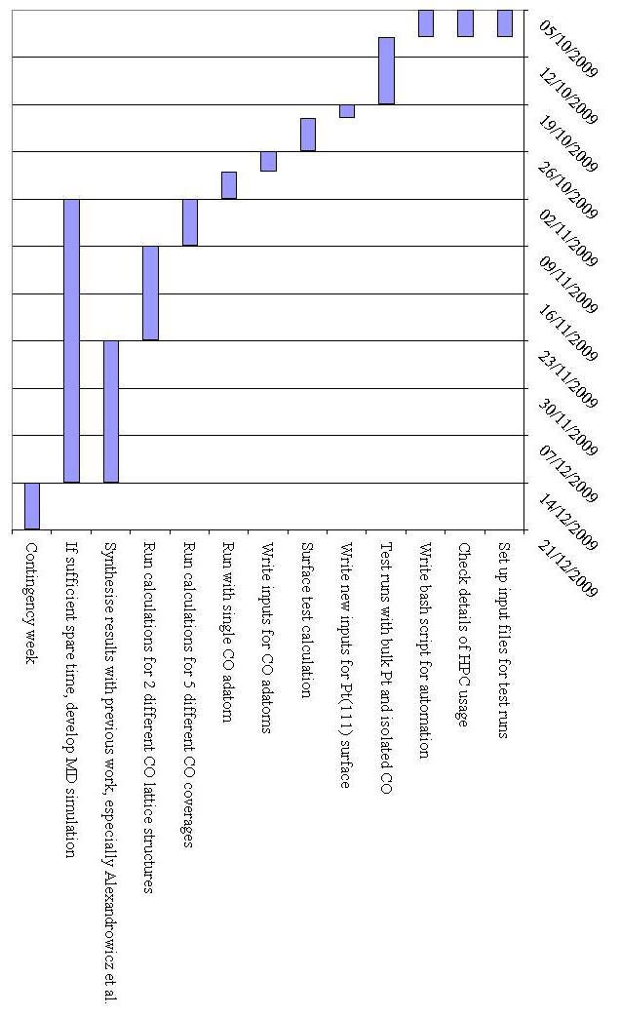
Figure 3. Gantt chart showing programme of work for the project, over its 11 week duration. Weeks start on a Monday, hence the last two days of each week are not actually used.

4.2. Risks
Table 1 shows the risks associated with the project. Where possible, ways of mitigating them have been suggested, although this is not possible for all of them. However, for the MD failure, this is an optional objective so mitigation is not essential. This risk will occur if there is not enough time to develop the MD code properly, so it represents more a potentially overly-ambitious objective than a serious risk. Three of the risks are averted by essentially common computing practice: backups, updates and knowledge of maintenance periods, whilst the final risk requires more thought. To mitigate this, before the project is commenced more detailed research into the mechanics of running the codes (including bash scripting, HPCC configuration, FORTRAN [which the codes are written in], and the input file format).

Table 1. Risks associated with the project.
Risk | Effect | Likelihood score | Impact score | Overall | Mitigation
Failure of the HPCC | Delays whilst waiting for repair | 1 | 10 | 10 | None possible
Shorter HPCC maintenance periods | Short delays | 4 | 5 | 20 | Check maintenance dates in advance to ensure codes were not scheduled to be run then
Loss of saved data or report | Potentially massive amount of work to repeat | 3 | 9 | 27 | Regular backups
Bugs in PW-SCF code | Loss of individual run data | 6 | 2 | 12 | Check for updates regularly
Failure of MD code | Unable to fully reproduce Alexandrowicz 2008 | 6 | 3 | 18 | None possible
User errors in PW-SCF input file | Incorrect results | 5 | 4 | 20 | Make sure code is understood fully in advance, check results qualitatively after each run

4. Resources required
The resources required for the project are fairly straightforward: access to the University’s HPCC (which costs money), access to UNIX and a C compiler (for MD coding), ideally access to some of the original data being investigated, and time. The allocation of time has been shown in figure 3 already, so will not be discussed here. The University provides access to UNIX servers and C compilers for all students.

Access to the HPCC is charged at a flat rate by the University of 50p per node hour. It is estimated that the longest calculations will take 50 node hours. There are at least 9 long calculations (for CO coverage and lattice), possible repeats, as well as various shorter ones, including the tests. This could result in a total usage of around 1000 node hours, for a total cost of £500. It is not possible to reduce usage significantly below this and still gain a reasonably sized, accurate set of results. One factor that may even increase this usage is convergence tests: these are used to check the plane-wave basis set used is large enough [7]. Results that have not been converged have much higher error estimates, as the approximations may be having a large effect. Therefore convergence tests will be carried out. It is estimated that the largest usage, if several of these tests are required, will be 1500 node hours, for a total cost of £750. The Department will fund the project as long as usage is careful and well-planned, to keep costs as low as possible.

The original data may be available by arrangement with the Alexandrowicz group, but this has not yet been investigated. This would be useful, as the equipment required to replicate these results would be extremely expensive and complicated.

5. Project management
The project will largely be carried out independently, following the plan laid out in figure 3. This plan will be stuck to as far as possible, unless spare time allows it to be brought forward. As far as possible, a constant stream of calculations will be placed in the HPCC queue: when one has finished, the next will be added. The time when one is running can be used to prepare the next calculation. This will save much time. Whether to develop an MD simulation as well will be decided around week 5 or 6, to allow sufficient time for development.

The project will be under the supervision of Professor David Bird, allowing for useful advice but not day-to-day involvement.

6. Ethical and health-and-safety issues
There are no known ethical issues for this project. It does not involve confidential research, or any research which could have a direct effect on other people.

There are also no particular health-and-safety issues beyond standard computing issues (i.e. repetitive strain injury etc.). There are no dangerous substances involved, nor in fact any physical research. All research is computational.

7. Dissemination of results
As discussed earlier, results will primarily be disseminated by a written report and a short presentation. This report will be assessed by independent academics. If it is of a high-enough standard, it may potentially be submitted to an e-print server. The presentation will last roughly 30 minutes and will be given at the Department’s annual Placement Conference, in front of fellow students, assessing academics, and other interested parties. If the results prove interesting, then a poster presentation may also be given at a scientific conference.

References

